Week 4

IBM Data Science Professional Course Applied Capstone

**Opening a New Halal Restaurant in London, England**

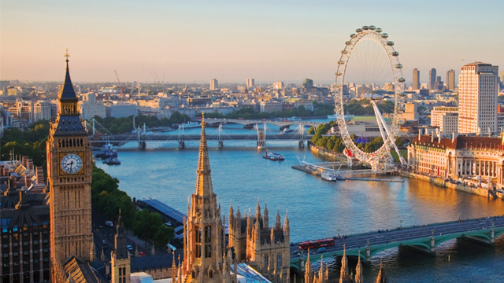

By: Bilal Siddiqui

August 2019

**Introduction**

One of the most difficult things for certain people whether it is for religious reasons, specialty needs, or just because they want to eat healthy is locating a halal place to eat. They can always locate a vegetarian restaurant or go into a restaurant that does not provide halal options, but they do not get the same satisfaction as they could have had. Businesses are losing out on hundreds of potential customers because of a lack of halal options around the area. The city of London is one of the largest populated cities in the world. Opening a restaurant that caters to all dining needs including halal options will allow a business to increase revenue significantly. What else? Deciding where to open the restaurant is one of the most important decisions any business professional can make.

**Business Problem**

We have determined problem as the difficulty of finding halal options within an area to satisfy all customers needs. Our objective is to determine the best location in the city of London to open a new halal restaurant. Using the data science methodology steps we have learned throughout this course such as data mining, machine learning techniques, and more, we aim to help an individual answer this problem: Where is a good place to open a halal restaurant in the city of London?

**Data**

In order to open our new halal restaurant in London, England, we will need:

* Gather the neighborhoods in London, the capital of England to define the scope of our problem.
* Latitude and longitude coordinates of the neighborhoods we gathered for the city of London
* Venue data on restaurants to perform machine learning algorithms on the data specifically clustering.

**Sources**

In order to get the neighborhoods for our analysis we will be using the following link: (<https://www.airbnb.com/locations/london/neighborhoods>) provided by Airbnb. Airbnb is an online hospitality service that members use to arrange lodging, temporary stay, our tourism experiences. The link provides 48 neighborhoods in London that we will use through web scraping from the ‘BeautifulSoup’ library to extract the data.

We will then using the Python geocode package to obtain the latitude and longitudes of the neighborhoods we have extracted.

Finally, we will use the Foursquare API to get the venue data on the London neighborhoods particularly restaurants.